MINISTRY OF SCIENCE AND EDUCATION NATIONAL TECHNICAL UNIVERSITY “KHARKIV POLYTECHNIC INSTITUTE”

DEPARTMENT OF SOFTWARE ENGINEERING AND MANAGEMENT INFORMATION TECHNOLOGIES

Report from lab#3

Discipline “Fundamentals of DataBase”

Executed by: Student of group 1.КН.201.8г

CHUKWU IRELE AMORIN

Checked by:

**Assistant Polovinka O.L.**

Kharkiv

2019

**Topic :** CREATE MULTITABLE FORMS USING DBMS ACCESS

Create Add Data Form :

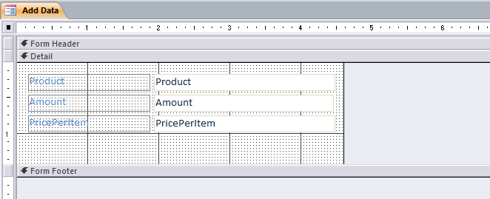

Create Supply information Form :

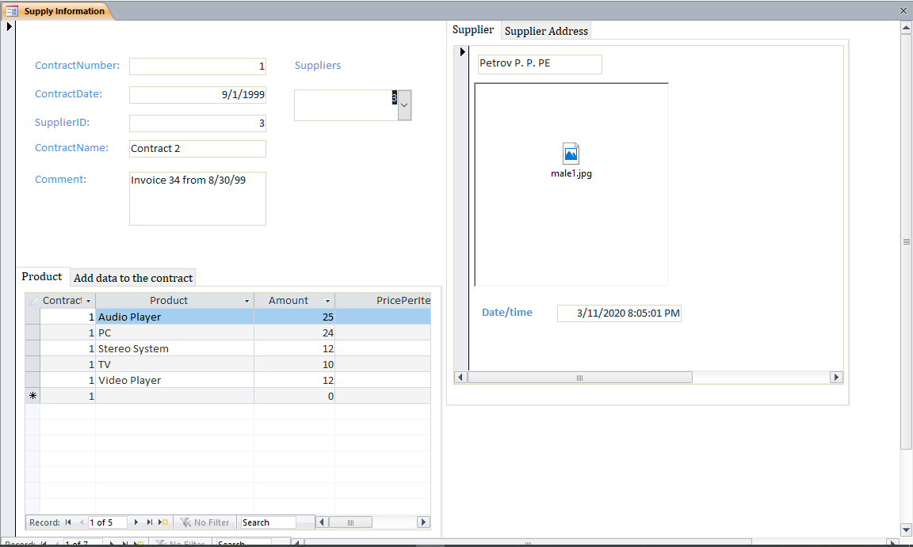

Main Form In Design view :

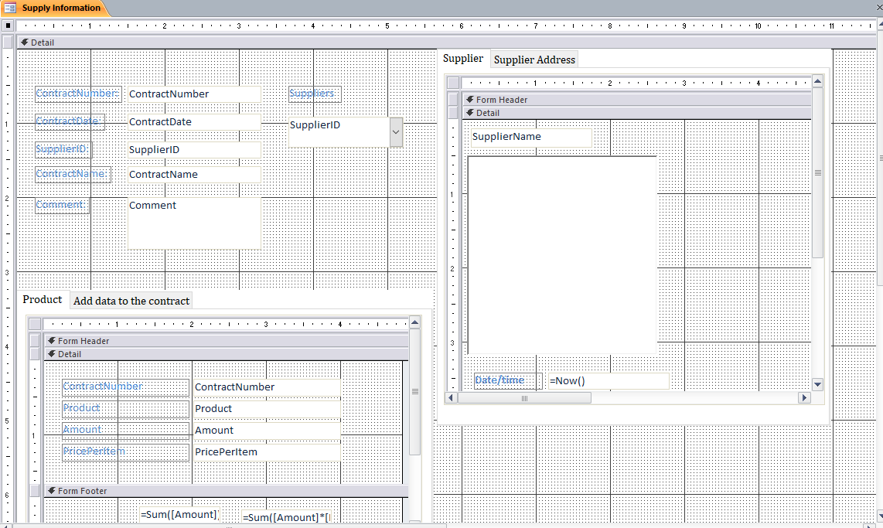

Briefly describe basic steps of this work:

* Created each component of the form .
* Created required subforms , added required textboxes , labels , tab controls ,combo boxes , buttons .
* Bounded the required fields.
* And resized each component to fit in .

properties sheets : used to edit the attributes and “look and” feel of various components .

textbox: used in representation of a field

Describe usage of forms to work with data: used to view existing data and input data into our database

**Conclusion :**

At that lab were received knowledges about Forms method it`s usage and gotten practical skills that allows to create database using DBMS Access in this environment. There were also known how inputting data, editing data, and viewing data, and designed for the monitor and viewing data. using DBMS Access.